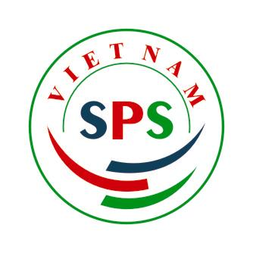
Bridge for safety life | Vietnam Sanitary and Phytosanitary Notification Authority and Enquiry Points  Address: 2 Ngoc Ha street. Hanoi. Vietnam  Telephone: 84 4 7344764  Fax: 84 4 7344764  Email: spsvietnam@mard.gov.vn  Website: www.spsvietnam.gov.vn

To: | Central Registry of Notifications  World Trade Organization | Fax: (+41 22) 739 5197
Copy: | Draft No.10: Regulations on management of hygiene and safety of food originated from gene-modified organisms
Date: | January 29, 2008
From: | Hoang Thi Dzung  Director of Vietnam SPS National Notification Authority
Subject: | G/SPS/N/VNM/05  VNM/SPS/N/05-2008-FS
Number of pages (including this cover sheet): 6 pages
ROUTINE SPS NOTIFICATION FROM VIETNAM
Please find enclosed a routine SPS notification from VIETNAM.
Thank you for your assistance.

Yours sincerely,

Hoang Thi Dzung
Director
Vietnam SPS National Notification Authority

